Import data using transform map using spread sheet (Proposed Solution)

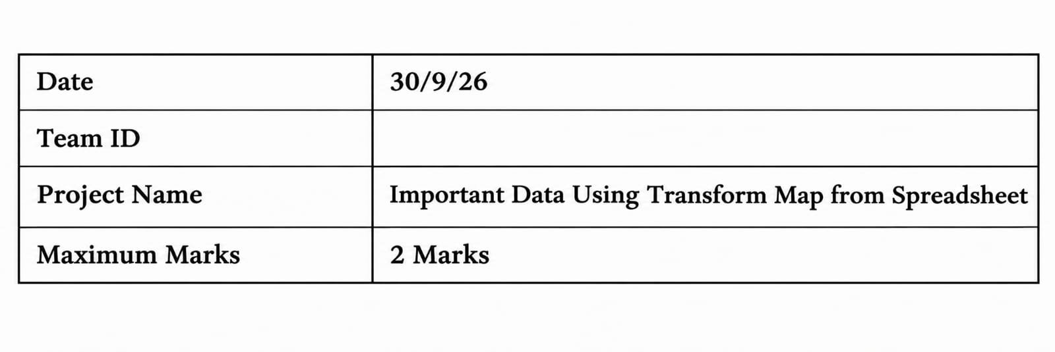

1. Problem Statement
Many organizations maintain employee information in Excel spreadsheets. Manually entering this information into ServiceNow can take time and may result in duplicate records, incorrect data, or missing information. There is a need for a simple and automated solution to import employee data accurately and efficiently.

2. Idea
The proposed solution uses ServiceNow Import Sets and Transform Maps to import employee information from an Excel spreadsheet. The spreadsheet contains Employee ID, Name, Email, Department, and Location.
The data is first loaded into the Import Set Table for temporary storage and validation. The Transform Map then maps the spreadsheet fields to the Employee table. Employee ID is used to identify existing employees. If the ID exists, the record is updated; if the ID does not exist, a new employee record is created.

3. Novelty
The solution provides an automated approach to employee data management using a standard ServiceNow import process. Instead of manually creating or updating employee records, the system uses Transform Maps and Employee ID matching to process records automatically.
The solution also separates the import and transformation stages, allowing data to be checked before it reaches the final Employee table.

4. Social Impact
The solution can reduce repetitive manual work for HR teams and help them manage employee information more efficiently. Accurate employee records can support HR activities and improve access to employee information.
The solution can also reduce errors caused by repeated manual data entry and provide a more consistent process for maintaining employee records.

5. Business Model
The solution can be used by organizations that manage employee information in spreadsheets and ServiceNow. It can be implemented as part of an organization's existing ServiceNow environment.
The business value comes from reducing manual effort, improving data consistency, and providing a repeatable employee data import process. Organizations can adapt the solution for different departments or employee-data requirements.

6. Scalability of Solution
The solution can be expanded to handle larger numbers of employee records and additional employee fields. More fields such as Phone Number, Job Title, Manager, Joining Date, and Employment Status can be added to the spreadsheet and Transform Map when required.

